Work Breakdown Structure (WBS)
LitPath AI: Smart Pathfinder for Theses and Dissertations

Asia Pacific College
3 Humabon, Magallanes
Makati City, Metro Manila 1232

April 1, 2026

Introduction
The Work Breakdown Structure presented here represents all the work required to complete this project.

Outline View
1. DOST LitPath AI – APC 2025-2026 T1 MI231 G07 HecTech
1.3 3.0 Executing Phase
1.3.1 3.1 Usability Testing
1.3.3 3.3 Pre-deployment
1.3.5 3.5 Release & Finalization (System Dry-run)
1.3.11 Feature 11.0 Targeted Dormant Material Export
1.4 4.0 Monitoring and Controlling
1.4.1 4.1 Tracking Progress
1.4.2 4.2 Comparing it to the Plan
1.4.3 4.3 Identifying any Deviations or Issues
1.4.4 4.4 Measuring Performance
1.4.5 4.5 Performance Reporting
1.4.6 4.6 Risk and Issue Management
1.4.7 4.7 Quality Assurance and Control
1.5 5.0 Closing Phase
1.5.1 5.1 Completing All Tasks
1.5.1.1 5.1.1 User Acceptance Test Completion
1.5.2 5.2 Obtaining Final Approvals
1.5.3 5.3 Archiving Project Documentation
1.5.4 5.4 Conducting a Final Review
1.5.5 5.5 Project Turnover

Hierarchical Structure
Level | WBS Code | Element Name
1 | 1 | DOST LitPath AI – APC 2025-2026 T1 MI231 G07 HecTech
2 | 1.3 | 3.0 Executing Phase
3 | 1.3.1 | 3.1 Usability Testing
3 | 1.3.3 | 3.3 Pre-deployment
3 | 1.3.5 | 3.5 Release & Finalization (System Dry run)
3 | 1.3.11 | Feature 11.0 Targeted Dormant Material Export
2 | 1.4 | 4.0 Monitoring and Controlling
3 | 1.4.1 | 4.1 Tracking Progress
3 | 1.4.2 | 4.2 Comparing it to the Plan
3 | 1.4.3 | 4.3 Identifying any Deviations or Issues
3 | 1.4.4 | 4.4 Measuring Performance
3 | 1.4.5 | 4.5 Performance Reporting
3 | 1.4.6 | 4.6 Risk and Issue Management
3 | 1.4.7 | 4.7 Quality Assurance and Control
2 | 1.5 | 5.0 Closing Phase
3 | 1.5.1 | 5.1 Completing All Tasks
4 | 1.5.1.1 | 5.1.1 User Acceptance Test Completion
3 | 1.5.2 | 5.2 Obtaining Final Approvals
3 | 1.5.3 | 5.3 Archiving Project Documentation
3 | 1.5.4 | 5.4 Conducting a Final Review
3 | 1.5.5 | 5.5 Project Turnover

Tabular View
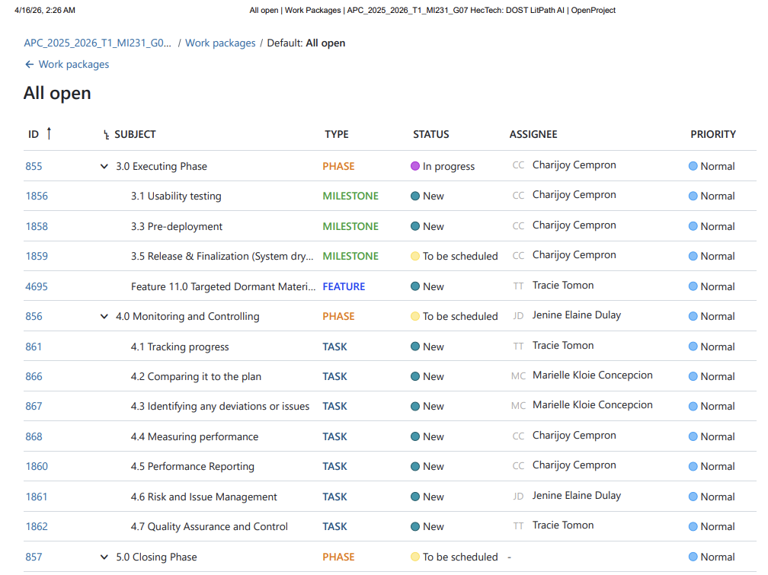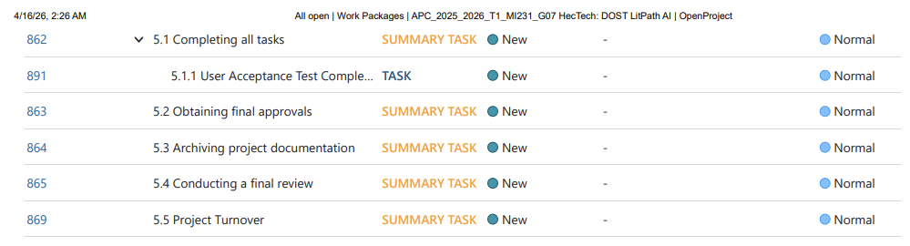

Tree Structure View

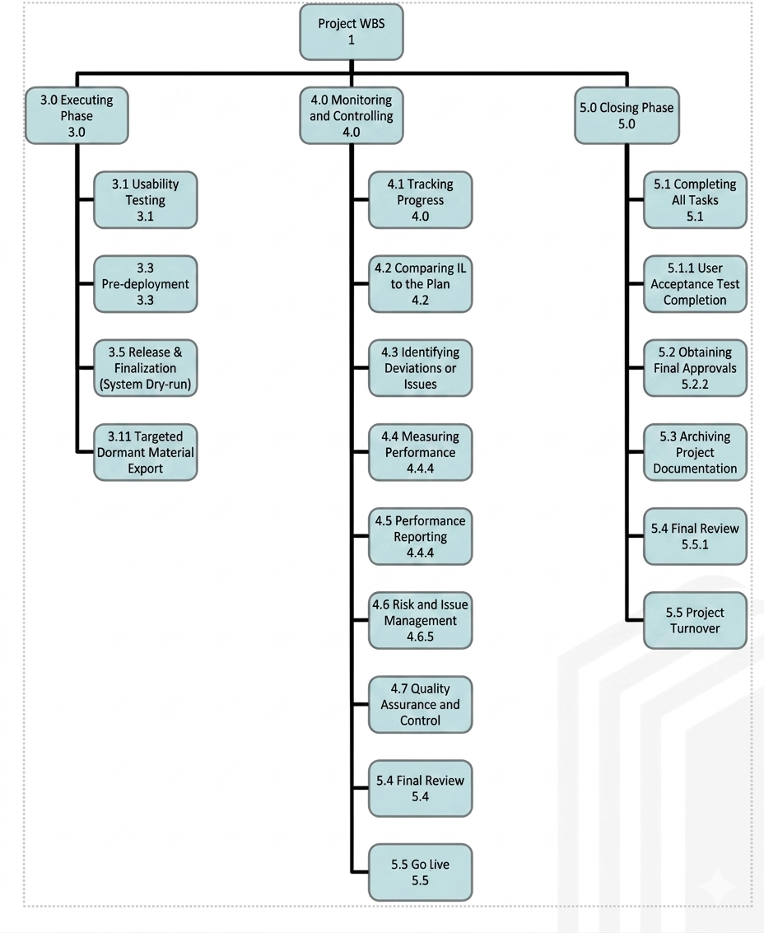

WBS Dictionary

AY 2025-2026 T3 Sprint 01
Sprint Period: 03/23/2026 – 04/03/2026 Total Points: 80 Total Features: 12
Level | WBS Code | Element Name | Definition
1 | 1 | Feedback Management System | All work to implement and deliver features under AY 2025-2026 T3 Sprint 01.
2 | 1.1 | AY 2025-2026 T3 Sprint 01 | Sprint covering the period 03/23/2026 – 04/03/2026 with a total of 80 story points across 12 feature items.
3 | 1.1.1 | Feature 1.0 User Account Registration System | Implement the user account registration system including sign-up forms, input validation, account creation logic, and confirmation workflows. (8 points, Issue #4674)
3 | 1.1.2 | Feature 2.0 LLM Source Accuracy Optimization / Enhance Prompt | Optimize the accuracy of LLM-generated responses by refining source selection logic and enhancing prompt engineering techniques to improve output quality and relevance. (10 points, Issue #4679)
3 | 1.1.3 | Feature 3.0 Welcome Page & Form UI Modernization | Blur the picture in the welcome page and associated form interfaces to improve user experience, visual consistency, and accessibility standards. (5 points, Issue #4689)
3 | 1.1.4 | Feature 4.0 Display Philippine Standard Time (PST) | Update all date and time displays throughout the application to reflect Philippine Standard Time (PST, UTC+8), ensuring consistent localized timestamps across the system on both user and admin side. (5 points, Issue #4690)
3 | 1.1.5 | Feature 5.0 Clickable Modal Interface (Feedback Manager) | Turn the Feedback Manager into a clickable modal interface to allow admin to view detailed feedback entries in an overlay dialog without leaving the current page context. (5 points, Issue #4692)
3 | 1.1.6 | Feature 6.0 UI Decluttering (Feedback Table View) | Declutter the Feedback Table View by removing redundant elements, removing columns, and improving the overall layout for enhanced readability and usability. (7 points, Issue #4693)
3 | 1.1.7 | Feature 7.0 Data Pagination (Feedback Manager) | Introduce data pagination functionality to the Feedback Manager in the Admin Dashboard to efficiently handle large datasets, enabling users to navigate through records in manageable pages. (7 points, Issue #4694)
3 | 1.1.8 | Feature 8.0 Targeted Dormant Material Export | Develop an export feature that allows administrators to selectively export dormant materials from the system based on defined criteria, supporting data management and archival processes. (8 points, Issue #4695)
3 | 1.1.9 | Feature 9.0 Failed Query Keyword Tracking | Implement a tracking mechanism to capture and log keywords from failed search queries, enabling the team to identify content gaps and improve system coverage over time. (8 points, Issue #4696)
3 | 1.1.10 | Feature 10.0 "Least Viewed" Metric Tracking | Build a metric tracking system that identifies and monitors the least-viewed content items, providing insights to inform content curation and resource prioritization decisions. (8 points, Issue #4697)
3 | 1.1.11 | Feature 11.0 Column Merger & Analysis Dropdown Refinement | Merge related data columns and refine the analysis dropdown menus to reduce redundancy, improve navigation clarity, and streamline the analytical workflow for admin users. (4 points, Issue #5100)
3 | 1.1.12 | Feature 12.0 Explicit Date Formatting & "Feedback Type" Column Renaming | Standardize date formatting across the application with explicit format definitions and rename the Feedback Type column for improved clarity and consistency in the data presentation layer. (5 points, Issue #5101)
All features have a status of Closed as of the sprint end date.

Glossary of Terms
Level of Effort (LOE):
Level of Effort (LOE) refers to the amount of work, time, and resources required to complete a specific task or activity. It is typically used for support-type tasks that do not produce a tangible deliverable but are necessary for project completion.
WBS Code (WBS Number):
A WBS Code, also commonly referred to as a WBS Number, is a unique identifier assigned to each element in a Work Breakdown Structure. It indicates the hierarchical position of a component within the WBS and is used for tracking, organization, and reference purposes.
Work Package:
A Work Package is the lowest level of a WBS branch. It represents a deliverable or a specific unit of work that can be assigned, scheduled, and tracked. Work Packages are defined clearly enough to allow estimation of cost, duration, and resources.
WBS Component:
A WBS Component refers to any element within a Work Breakdown Structure at any level of the hierarchy. It may represent a Work Package or a higher-level grouping of work. All elements in the WBS are considered WBS Components regardless of their level.
WBS Element:
A WBS Element is any individual item within the Work Breakdown Structure that may exist at any level of the hierarchy. It can represent a delivery, a grouping of tasks, or a Work Package. A WBS Element may contain other WBS Elements or Work Packages depending on its level in the structure.

